C-603 Reboiler – E-608

E-608 is the reboiler for C-603(DEG column). This reboiler was cleaned during June 2021 with majority of foulant found at the bottom cover. The maximum rundown flow of C-603 is 2.7T/hr. Currently the rundown flow is maintained at an average of around 1.2T/hr.
Based on the trends of Heat transfer co-efficient and PV/MV ratio of E-608, there is not any strong evidence that indicates the reboiler fouling.
Below is the trend for Heat transfer co-efficient trend for E-608
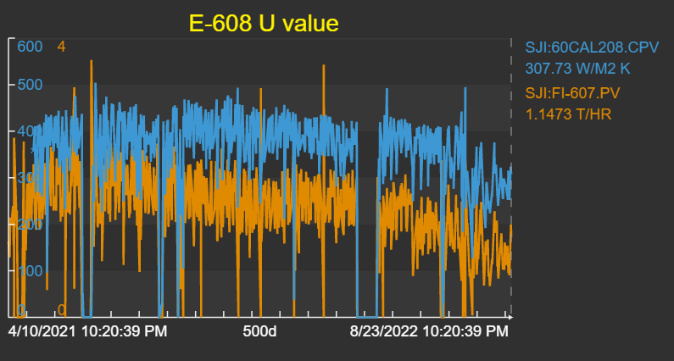
Based on the above trend, the downtrend of Heat transfer coefficient (blue line) is due to the run down flow (saffron line) we are maintaining now. Thus reduces the Load to the column and so it is reflected in the ‘U’ calculation.
The initial/Usual check on any steam heat exchanger is PV/MV ratio. Below is the PV/MV ratio of E-608.
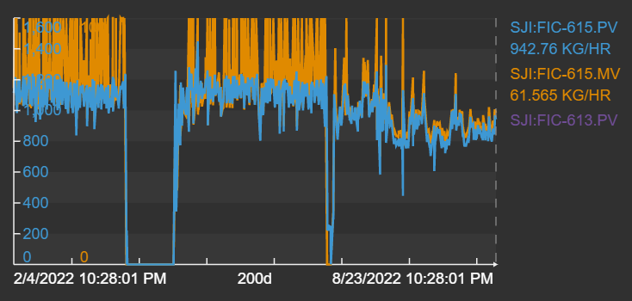
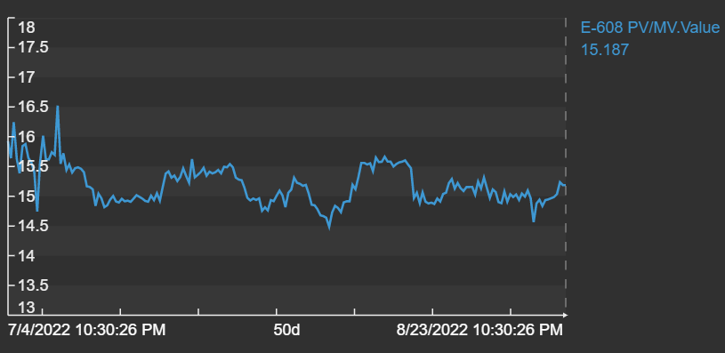
The above PV/MV ratio trend of E-608 also not showing any strong evidence for fouling.
Currently the FIC-615 (22K steam flow to E-608) MV opening is maintained at around 55% to 60% opening to maintain the flow of 0.85T/hr to 0.94T/hr of steam which is enough for the current rundown flow around 1.2T/hr. Still there is a margin to increase the steam flow if higher rundown flow is required in future.

