Recurrence of HC Leak into SCW Loop via E224

Investigation Team members
Name | Function | Commitment
Manikandan Nagarajan | Inspection Engineer and CL Team Lead | Full time
Vincent Koh | CL Facilitator | Full time
Goh Phoi Chin | PU1 Materials & Corrosion | Full time
Reggy Franz | P&T M&C Specialist | Full time
Neo Wei Hao | Process Technologist | Part time
Introduction
Hydrocarbon (HC) leak into sea cooling water (SCW) loop via exchanger E-224 was reported on 12th June 2019. PU1 (Unit 100 to 400) was shut down for 5 days for investigation and repair work. This is a second occurrence, 11 months after the first leak reported on 5th July 2018. The leak was again caused by crevice corrosion at the gasket seat surface of the floating head.
During causal learning in 2018, various driving factors that could lead to crevice corrosion at the floating head cover causing Loss of Primary Containment (LOPC) were evaluated. Insights of each observation were discussed and documented¹. Unfortunately, another LOPC caused by the similar corrosion mechanism at the gasket seat of the floating head was reported 11 months after operation resumed. Another causal learning session was then initiated to understand the root cause of this LOPC, this report documents the findings.
Incident Background
In U-200, 11 wt% EBHP is concentrated to 30 wt% EBHP through a 2-stage vacuum flashing in V-201 and V-204. The concentrated EBHP is then routed to E-224, which cools down the flashed EBHP product from 84ºC to 60ºC, before entering U-200 wash train. During normal operation, the shell side (EBHP) of E-224 is operated at a higher pressure (6.5 barg versus 3.5 barg) than the tube side (SCW) (Appendix A).

E-224 was commissioned in 1997. In 1998, the tube bundle material was upgraded from SMO 254 to Titanium. The shell material remained as SS 316 while the floating and channel head cover materials remained as SMO 254. Two resistor-controlled Cathodic Protections (RCPs) were also installed at the channel head cover to prevent crevice corrosion of SMO 254 in the SCW system. Since then, E-224 was operated with mixed metallurgy. No major corrosion issue was observed until the failure in 2018. Only minor crevice corrosion at the channel head gasket seat was reported during the turnaround (TA) 2011 but not observed in TA2016.

In July 2018, 23 months in operation after TA2016, the first on-the-run leak was reported at E-224. The leak was caused by crevice corrosion at 5 locations of the gasket seat surface of the floating head. This led to a shutdown of the unit and a production loss of 5 days. The SMO 254 gasket seat surface was then repaired with weld build-up at the damaged location with Inconel 625, which has a higher resistance to crevice corrosion² in seawater system, at the crevices and reinstated for production.

Incident Description (“Timeline”)
On the 5th of June 2019, the online Total Organic Carbon (TOC) analyser (16QR010) at the SCW green return header 2, measured higher readings and remained as a standing alarm (Appendix B). A sample of SCW was then collected for visual check and no abnormalities were found. On the 11th of June 2019, re-sampling of SCW was done and again no abnormalities were found. On the 12th of June 2019, QMI was activated to validate 16QR010. After confirming the higher measured TOC readings from 16QR010, various SCW return samples were collected from the suspected heat exchangers (i.e. E-112, E-219, E-224) for laboratory analysis. On the 12th of June 2019 afternoon, the leak was confirmed at E-224. PU1 then proceeded to shut down and released for inspection and repair.

Before the shutdown of E-224, the electrical potential of the two RCPs at the channel head were measured. The measured potentials were within the expected range. On 13th Jun 2019, a hydrostatic test was conducted at the tube side of E-224. The leak was then identified at the floating head cover. After removal of the floating head cover, crevice corrosion was observed at 3 locations of the SMO 254 (A240 UNI S31254) gasket seat surface (Figure 1). Maximum depth measured was 5 mm (Figure 2). The short-term solution was to machine and weld overlay both the gasket seating surface and the floating head cylindrical internal surface with Inconel 625.
A hydrostatic test was also conducted at the shell side of E-224. No leak was observed. The two RCPs were visually inspected. Anode consumption was estimated to be ~20%.
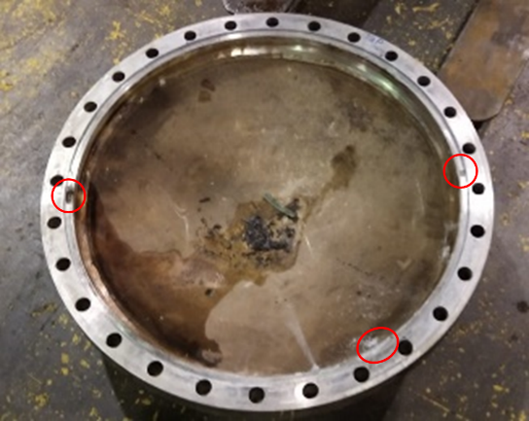 | 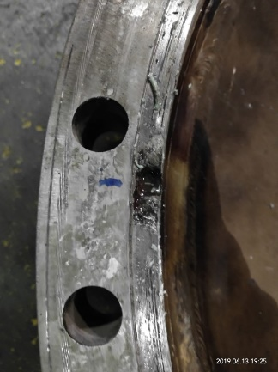
Figure 1: Crevice corrosion at the gasket seat surface of the floating head cover. | Figure 2: Crevice with a maximum depth of 5 mm

Problem Statement
Expected: | E-224 shall run between 2 TAs (5 years duration) with EB contained in the process side and SCW contained in the cooling medium side.
Actual: | EB leaked into SCW loop via the floating head gasket seat of E224.  - The first leak occurred in July 2018 (23 months after TA2016)  - The second leak occurred in Jun 2019 (11 months after the first leak)
Impact: | 5 days UPDT (shutdown of PO1)  LOPC of about 48 kg/h of hydrocarbon into SCW  Production loss estimated as USD 11.3 mil  Actual unplanned repair cost of about USD 200 K

Event Timeline
Refer to Timeline Diagram in Appendix
Year | Events
1997 | E-224 was commissioned  Tube bundle and floating head cover material was SMO 254
1998 | Tube bundle material was upgraded to Titanium, floating head cover remained in 254SMO  Two new RCPs was installed at the channel head
2006 | Gasket seat of the floating head was inspected during TA with no finding  Some salts pieces found at shell side
2011 | Slight crevice corrosion found at gasket seat of tubesheet at channel side during TA  RCPs reassessment was performed and found to be adequate  RCPs were replaced with a new set
2016 | Gasket seat of the floating head was inspected during TA and no finding  V-204 was operated at lower pressure and temperature after SSF1 commissioned.  Inlet temperature at shell side dropped from 94°C to 84°C  Gasket vendor changed from Tat Lee to James Walker  Camprofile mica gasket was installed, then replaced with Camprofile Novapress Universal  ~50% of RCPs was consumed since 2011  RCPs were replaced with a new set during TA  Some salt pieces found at shell cover during TA  Tubesheet, split and backing rings were installed, removed and re-installed during TA  Split rings were installed in a reverse manner
2017 | E-202 leak reported in March  EB fluid of E-224 was kept at standstill for 9 days during the shutdown
2018 | E-224 leak from floating head gasket seat causing EB leak into SCW loop reported in July  5 locations of crevice corrosion at floating head cover with the deepest depth of 5 mm  Repair of E224 with partial weld build-up of Inconel 625 at crevices  ~10% of RCPs consumed  RCPs were re-used during commissioning  Hypochlorite shock dosing duration was extended from 1 hour to 1.5 hour  E224 split rings were installed in reverse manner (noticed via photo)  The backing ring was installed in correct facing in July 2018
2019 | Hydrocarbon was detected in TOC analyser 16QR010 on 5th June  3 locations of crevice corrosion at floating head cover with the deepest depth of 5 mm  Repair of E224 via an overlay of the entire gasket seat surface and the floating head cylindrical internal surface with Inconel 625  Deformation of split rings and the backing ring was noticed  Split rings and backing ring were replaced  ~20% of RCPs was consumed. RCPs were re-used during commissioning

Why it happened (“Cause and Effect Diagram”)
Refer to the attached Cause and Effect Diagram in appendix
A combination of factors could have led to this incident:
- SMO 254 material of the floating head gasket seat is susceptible to crevice corrosion under the current operating condition in the SCW system. However, the rate of corrosion is expected to be slow and not to cause leak for at least 5 years, similar to the experiences of this floating head gasket before 2016 and other similar services.
- Several factors that contributed to the acceleration of crevice corrosion are:
- Incorrect installation of split rings at the floating head could have created a small opening at the gasket seat surface that accelerated the crevice corrosion
- Deformation of split rings and the backing ring could have created a small opening at the gasket seat surface that accelerated the crevice corrosion
- Plastic deformation of Class 1 bolt due to over-torqueing thereafter relaxation of the bolts after hydrotesting could have created a small gap at the gasket seat surface that accelerated the crevice corrosion
- Potential ingress of light acids from the process side further accelerated the crevice corrosion

Crevice corrosion
Crevice corrosion refers to corrosion occurring in confined spaces (stagnant zone) where the access of the working fluid from the environment is limited³. The corrosion mechanism involves two stages: the initiation and propagation. Crevice initiation on SMO 254 surface could occur due to the damage of the passive layer especially in the presence of chloride. For the propagation to take place, the crevice must be wide enough to allow the corroding electrolyte to enter and then provide 'stagnant' conditions. Unintentional creation of an opening (crevice) at the surface/joint could potentially accelerate the initiation stage and kick start the propagation stage of the crevice corrosion. The presence of corroding components such as acids, chloride, oxygen and others further accelerated the corrosion process.

Susceptibility of SMO 254 to crevice corrosion
The material of the floating head gasket seat is SMO 254. Cooling medium used at the tube side is SCW with the inlet temperature of ~35-36°C. There is a regular hypochlorite dosing in the SCW system to prevent fouling issue. Based on Ref.2, SMO 254 floating head gasket seat surface is susceptible to crevice corrosion under the current operating environment as the crevice critical temperature for SMO 254 is 30°C. As such, two RCPs are installed at the channel head cover to prevent crevice corrosion for the different materials in this exchanger. According to the vendor, Free Residual Chlorine (FRC) level must be maintained below 0.5 ppm to ensure the effectiveness of the RCPs. 56Q004 trend below (Figure 3) showed that the residual free chlorine level was mostly maintained below 0.5 ppm.
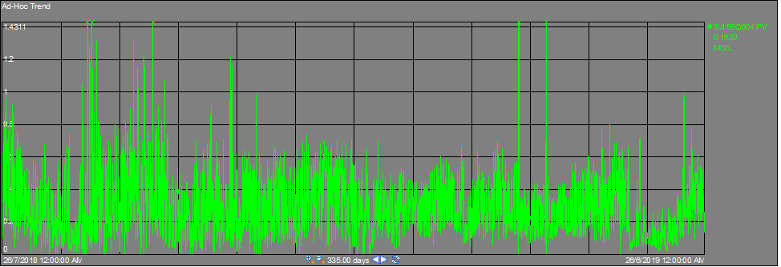
Figure 3: Trend of residual free chlorine level (56Q004)

Incorrect installation of split rings
After removal of the shell cover, the bottom section of the floating head was found slightly tilted (the floating head was not at 90° to the shell) (Figure 4). The split rings were then found installed in a reverse manner as compared to the GA drawing. The raised face was facing the floating head instead of the shell (Figure 5).
Further review of past inspection reports confirmed that the reverse installation was recorded during TA2016. During repair in 2018, the installation crew followed the 2016 installation sequence by following the yellow paint marks (Figure 3), which is not specific to the ring facing. According to the installation crew, it is the practice to reinstate back the installation the same way it was found and believed that it is the right way. Besides, the authorized engineer (AE) accepted the installation because the final visual inspection and installation checklist was completed with no issue reported.
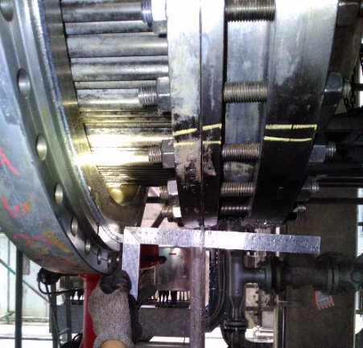 | 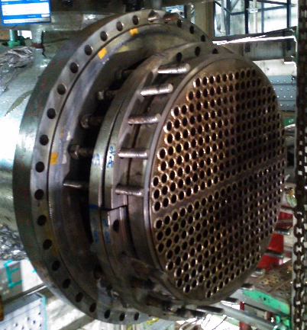
Figure 4: Slightly tilted floating head | Figure 5: Incorrect installation of split rings
Theoretical analyses showed that the reverse installation of split rings could cause insufficient compression between the floating head and the gasket after tightening, thus creating a long and narrow opening (Figure 6). SCW could then be accumulated and remained stagnant in this opening, limiting the diffusion of ions and accelerating the initiation and propagation stage of the crevice corrosion.

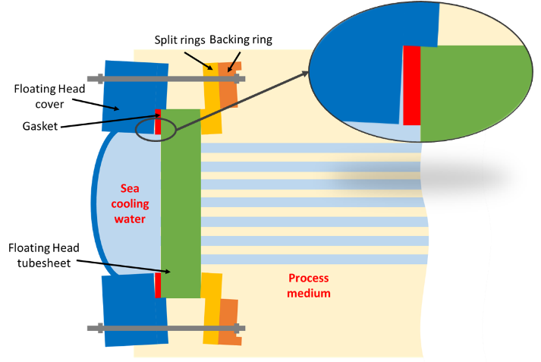
Figure 6: Small opening created due to incorrect installation

Deformation of split rings and backing ring
After dismantling of the split rings and backing ring, all rings were found deformed (Figure 7). The rising face of the backing ring was also found dented. Bolt marks were noticed at both sides of the backing ring (Figure 8). Based on the inspection history, only the split rings were installed in a reverse manner while the backing ring was installed correctly during TA2016 and repair in 2018. This implied that the backing ring has been installed in a reverse manner before TA2016.
Theoretical analyses showed the impact of deformed split rings and the backing ring could be the same as the impact due to reverse installation of split rings mentioned above.
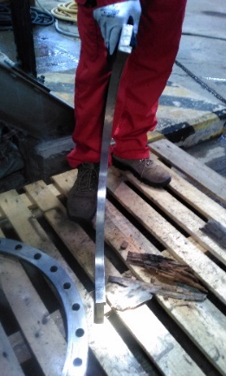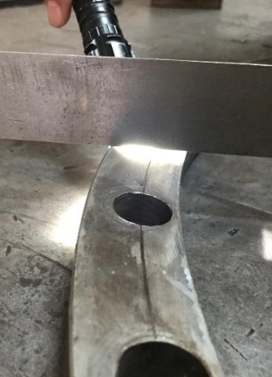 | 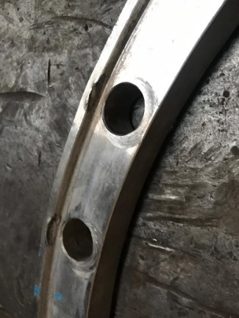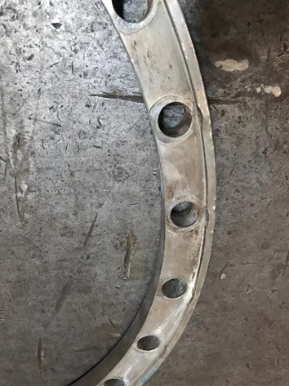
Figure 7: Deformed split ring and backing ring | Figure 8: Dented rising face and bolt marks on the backing ring

Plastic deformation of Class 1 bolts
During repair in June 2019, the torque value (TFA) used in the previous installation (2018) was noticed to be higher than the actual value (233 N-m versus 90 N-m) for Class 1 bolts. The detailed evaluation concluded that the high TFA value obtained was due to incorrect bolt class and flange thickness used in the calculation. Class 2 bolts were used instead of Class 1 bolts while Class 1 bolts were specified in the general assembly (GA) drawing. Flange thickness plus split rings and backing ring thicknesses were used for the TFA calculation instead of only flange thickness. These led to over-tightening of the floating head to the tubesheet in TA2016 and 2018.
Besides, a mixture of Class 1 (B8) and Class 2 (B8M) bolts were used in TA2016 and 2018. Among 28 bolts used, 21 bolts belong to Class 1 and 7 bolts belong to Class 2. Generally, Class 2 bolts have higher yield strength than Class 1 bolts. When higher TFA value was used, Class 1 bolts would experience partial plastic deformation. During the hydrotest, Class 1 bolts would be further plastically deformed as the hydrotest pressure is 1.5 times higher than the design pressure. After hydrotest, the plastically deformed bolts could not return to its original length, leading to the creation of a small gap at the gasket seat surface. Similarly, the presence of stagnant SCW zone could occur and accelerate the crevice corrosion.
The length measurement was performed on the 28 dismantled bolts. Among the 21 Class 1 bolts, 19 bolts experienced elongation of ~5-6 mm while 2 bolts experienced elongation of ~10mm. No elongation was found for the 7 Class 2 bolts (Figure 7). This further confirmed that Class 1 bolts were partially plastically deformed and there was uneven compression between the floating head and the gasket based on the different length of Class 1 bolts observed.
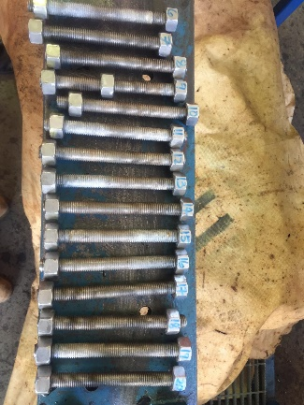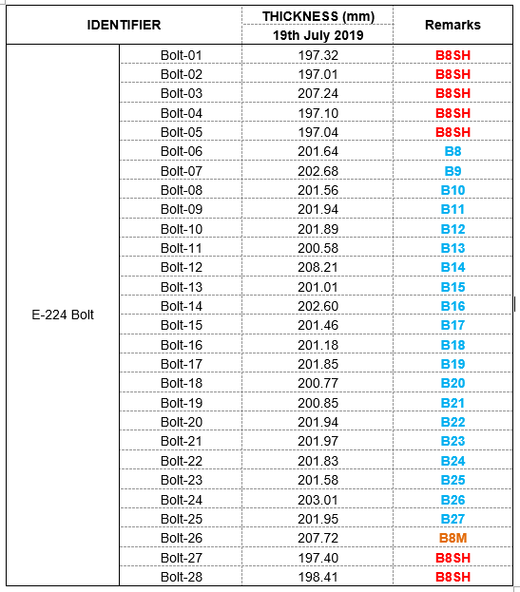
Figure 7: Length of the 28 dismantled bolts

Presence of light acids
In normal operation, the shell side pressure (6.5 barg) is higher than the tube side pressure (3.5 barg). It is known that the process fluid (EB) contains a small amount of light acids. In the presence of open path at the gasket seat of the floating head, light acids could diffuse into the crevice, increases the acidity of the stagnant SCW water and accelerates the crevice corrosion.
Learning (“OIC”)
- Reverse installation of split rings and backing rings could lead to deformation and cause insufficient compression between floating head and gasket, accelerating the crevice corrosion
  - The current site practice for the re-installation of static equipment (floating head heat exchangers in this case) is to re-install it the same way it was dismantled by the usage of paint marking. The site believes that if the equipment is re-installed back the same way, it’s the right way.
  - Current installation practice with paint marking on the component before dismantled could lead to incorrect installation if the previous installation was incorrect. Each contractor has their way of marking the equipment.
  - Marking to identify the position/orientation should be robust to prevent incorrect reassembly. GA drawing or technical document should be referred to verify the installation method.
- A mixture of Class 1 and Class 2 bolts with higher TFA value could lead to small gap creation that accelerated the crevice corrosion
- Bolt class for non-standard flange, calculated TFA value and GA drawing are inconsistent
  - In the TFA calculations, it was explicitly stated in the calculation sheet that Class 2 bolts were assumed for the calculations, but the equipment drawing indicated Class 1 bolts
Note:
One of the long-term proposals to prevent the recurrence of E224 leak in future is to upgrade the SMO 254 floating head cover to Titanium. Among the steel materials (e.g. carbon steel, stainless steel, SMO254, Hastelloy and titanium), Titanium has the highest resistance to crevice corrosion in the SCW system operated at 30-36°C. The above learnings indicate that the leak of E224 is primarily caused by the incorrect installation and deformation of split rings and the backing ring, and the presence of mixed bolt Classes and TFA value, leading to the acceleration of the crevice corrosion at the gasket seat of the floating head. Upgrading of floating head cover to Titanium would not be required.
Recommendations (“Corrective Action”)
 | Description of action | Action By | Due Date | Tracking (FIM/MTO)
1. | Implement an end-to-end QA/QC checklist for all type of heat exchangers to ensure that every AE and contractor who will work on heat exchangers to be able to:  - Confirm the correct materials, installation sequence and orientation of the parts being assembled (based on the technical documents e.g. Installation manual / GA drawings)  - Confirm the correct type of bolts are used - rating, materials, types, torque values (based on the technical documents e.g. GA drawings) | Roslan | 31st Dec 2019
2. | Emphasize the requirement in the Method Statement to always refer to technical documents e.g. installation manual or GA drawing to ensure correct installation sequence and orientation for floating head heat exchangers | Roslan | 31st Dec 2019
3. | Review the TFA calculation for stainless steel floating head for the possible use of difference bolt materials (class 1 and class 2), make the torque calculation document a controlled document and change the torque values for E224 floating head from 233 Nm to 90 Nm. | Harikrishna | 31st Dec 2019

References
- E224 Causal Learning Report 2018
- Roij, J. v. (2013). Material Selection Cooling Water HE - incl seawater. Shell Internal Reference
- https://www.nace.org/resources/general-resources/corrosion-basics/group-1/crevice-corrosion

Appendixes
- Schematic diagram of U200
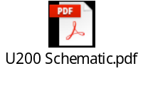
- UTL shift report
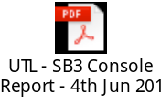
- Timeline
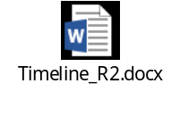

- Cause and Effect Diagram
